1.Ans 17.72 is the emissions per capita of Canada

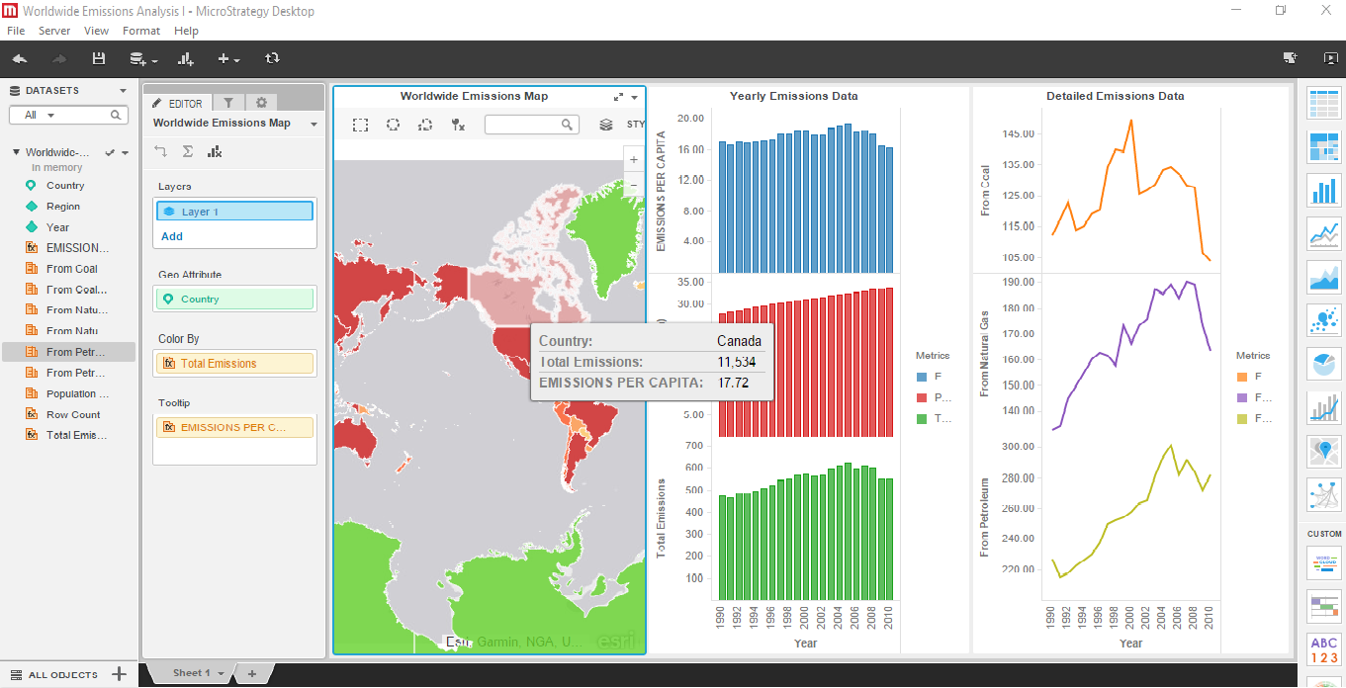

2.Ans Emissions are increasing each year except in 2009 where it decreased once.
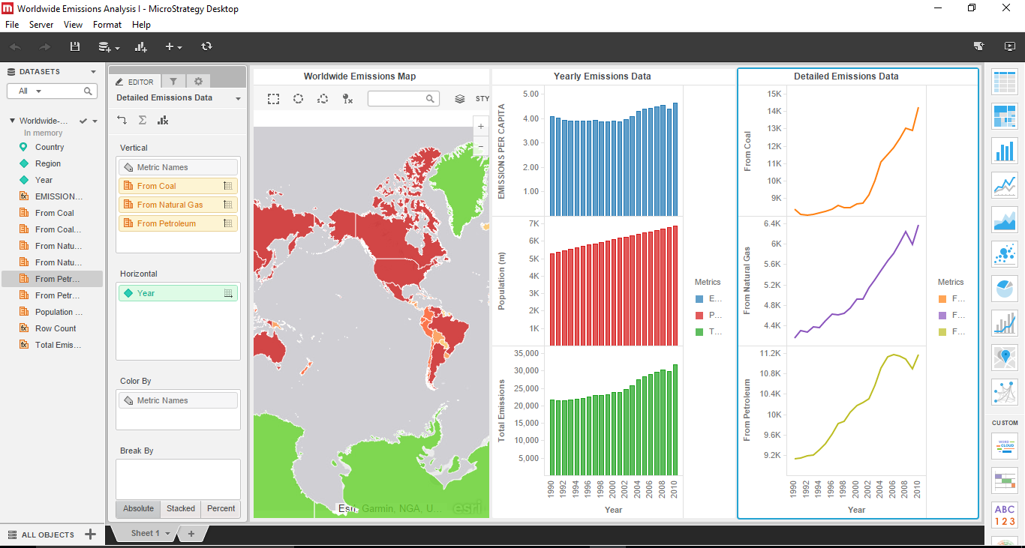

3. ANS Emissions decreases in 2009 due to global recession.

